**BUS TOPOLOGY**

**CODING:**

#Roll.No:20UIT021

#Name:R.SRIDEVI

#Date:30.07.2022

#Topology Name:Bus Topology

#Create a new simulator

set ns [new Simulator]

#Open the NAM trace file

set nf [open out.nam w]

$ns namtrace-all $nf

#Define a 'finish' procedure

proc finish {} {

global ns nf

$ns flush-trace

#Close the NAM trace file

close $nf

#Execute NAM on the trace file

exec nam out.nam &

exit 0

}

#Create four nodes

set n0 [$ns node]

set n1 [$ns node]

set n2 [$ns node]

set n3 [$ns node]

set n4 [$ns node]

set n5 [$ns node]

#Create links between the nodes

$ns duplex-link $n0 $n1 2Mb 10ms DropTail

$ns duplex-link $n1 $n2 2Mb 10ms DropTail

$ns duplex-link $n2 $n3 1.7Mb 20ms DropTail

$ns duplex-link $n3 $n4 1.7Mb 20ms DropTail

$ns duplex-link $n4 $n5 1.7Mb 20ms DropTail

#Call the finish procedure after 5 seconds of simulation time

$ns at 5.0 "finish"

#Run the simulator

$ns run

**OUTPUT:**

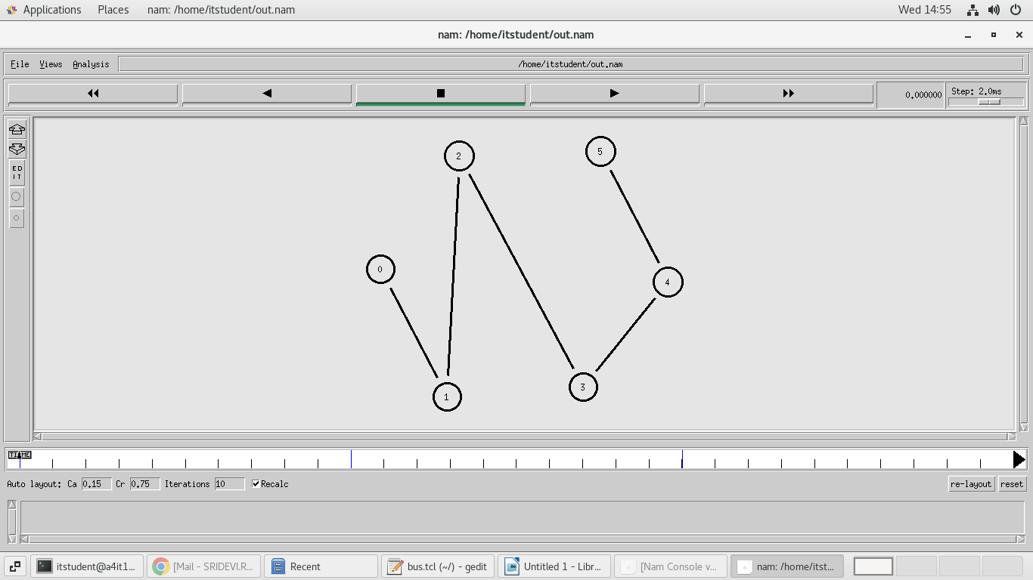

**RING TOPOLOGY**

**CODING:**

#Roll.No:20UIT021

#Name:R.SRIDEVI

#Date:30.07.2022

#Topology Name:Ring Topology

#Create a new simulator

set ns [new Simulator]

#Open the NAM trace file

set nf [open out.nam w]

$ns namtrace-all $nf

#Define a 'finish' procedure

proc finish {} {

global ns nf

$ns flush-trace

#Close the NAM trace file

close $nf

#Execute NAM on the trace file

exec nam out.nam &

exit 0

}

#Create four nodes

set n0 [$ns node]

set n1 [$ns node]

set n2 [$ns node]

set n3 [$ns node]

set n4 [$ns node]

set n5 [$ns node]

#Create links between the nodes

$ns duplex-link $n0 $n1 2Mb 10ms DropTail

$ns duplex-link $n1 $n2 2Mb 10ms DropTail

$ns duplex-link $n2 $n3 1.7Mb 20ms DropTail

$ns duplex-link $n3 $n4 1.7Mb 20ms DropTail

$ns duplex-link $n4 $n5 1.7Mb 20ms DropTail

$ns duplex-link $n5 $n0 1.7Mb 20ms DropTail

#Call the finish procedure after 5 seconds of simulation time

$ns at 5.0 "finish"

#Run the simulator

$ns run

**OUTPUT:**

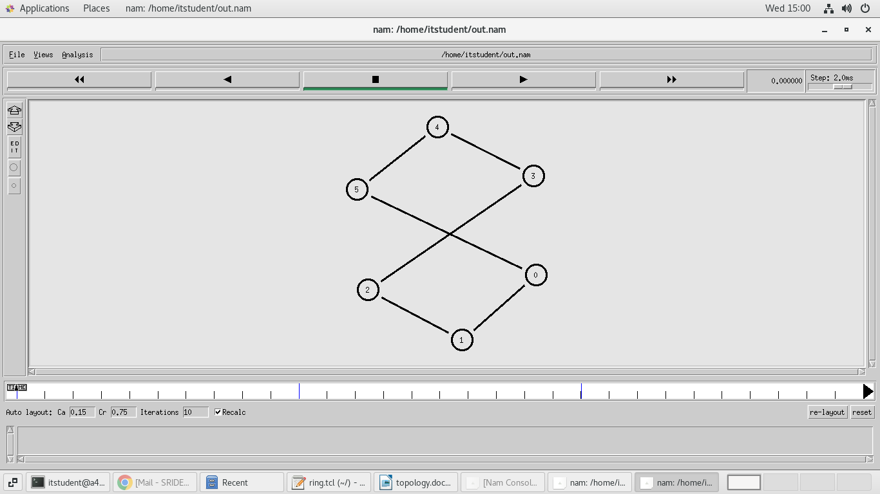

**STAR TOPOLOGY**

**CODING:**

#Roll.No:20UIT021

#Name:R.SRIDEVI

#Date:30.07.2022

#Topology Name:Star Topology

#Create a new simulator

set ns [new Simulator]

#Open the NAM trace file

set nf [open out.nam w]

$ns namtrace-all $nf

#Define a 'finish' procedure

proc finish {} {

global ns nf

$ns flush-trace

#Close the NAM trace file

close $nf

#Execute NAM on the trace file

exec nam out.nam &

exit 0

}

#Create four nodes

set n0 [$ns node]

set n1 [$ns node]

set n2 [$ns node]

set n3 [$ns node]

set n4 [$ns node]

set n5 [$ns node]

#Create links between the nodes

$ns duplex-link $n3 $n0 2Mb 10ms DropTail

$ns duplex-link $n3 $n1 2Mb 10ms DropTail

$ns duplex-link $n3 $n2 1.7Mb 20ms DropTail

$ns duplex-link $n3 $n4 1.7Mb 20ms DropTail

$ns duplex-link $n3 $n5 1.7Mb 20ms DropTail

#Call the finish procedure after 5 seconds of simulation time

$ns at 5.0 "finish"

#Run the simulator

$ns run

**OUTPUT:**

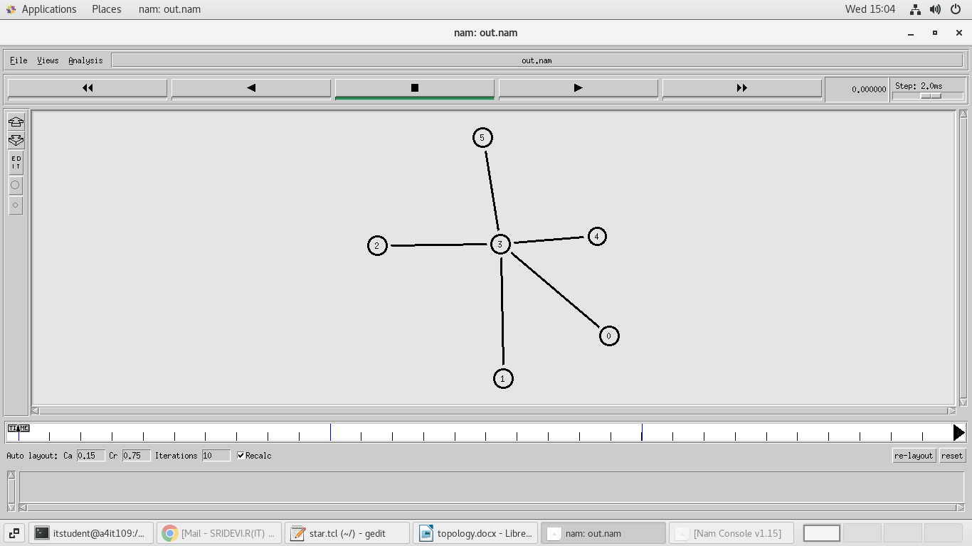

**MESH TOPOLOGY**

**CODING:**

#Roll.No:20UIT021

#Name:R.SRIDEVI

#Date:30.07.2022

#Topology Name:Ring Topology

#Create a new simulator

set ns [new Simulator]

#Open the NAM trace file

set nf [open out.nam w]

$ns namtrace-all $nf

#Define a 'finish' procedure

proc finish {} {

global ns nf

$ns flush-trace

#Close the NAM trace file

close $nf

#Execute NAM on the trace file

exec nam out.nam &

exit 0

}

#Create four nodes

set n0 [$ns node]

set n1 [$ns node]

set n2 [$ns node]

set n3 [$ns node]

set n4 [$ns node]

set n5 [$ns node]

#Create links between the nodes

$ns duplex-link $n0 $n1 2Mb 10ms DropTail

$ns duplex-link $n1 $n2 2Mb 10ms DropTail

$ns duplex-link $n2 $n3 1.7Mb 20ms DropTail

$ns duplex-link $n3 $n4 1.7Mb 20ms DropTail

$ns duplex-link $n4 $n5 1.7Mb 20ms DropTail

$ns duplex-link $n5 $n0 1.7Mb 20ms DropTail

$ns duplex-link $n0 $n4 2Mb 10ms DropTail

$ns duplex-link $n0 $n3 2Mb 10ms DropTail

$ns duplex-link $n0 $n2 2Mb 10ms DropTail

$ns duplex-link $n1 $n5 1.7Mb 20ms DropTail

$ns duplex-link $n1 $n3 1.7Mb 20ms DropTail

$ns duplex-link $n1 $n4 1.7Mb 20ms DropTail

$ns duplex-link $n2 $n0 1.7Mb 20ms DropTail

$ns duplex-link $n2 $n4 1.7Mb 20ms DropTail

$ns duplex-link $n2 $n5 1.7Mb 20ms DropTail

$ns duplex-link $n3 $n1 2Mb 10ms DropTail

$ns duplex-link $n3 $n5 2Mb 10ms DropTail

$ns duplex-link $n3 $n0 2Mb 10ms DropTail

$ns duplex-link $n4 $n0 1.7Mb 20ms DropTail

$ns duplex-link $n4 $n2 1.7Mb 20ms DropTail

$ns duplex-link $n4 $n1 1.7Mb 20ms DropTail

$ns duplex-link $n5 $n1 1.7Mb 20ms DropTail

$ns duplex-link $n5 $n3 1.7Mb 20ms DropTail

$ns duplex-link $n5 $n2 1.7Mb 20ms DropTail

#Call the finish procedure after 5 seconds of simulation time

$ns at 5.0 "finish"

#Run the simulator

$ns run

**OUTPUT:**

